**Service Catalog Item**

**2.1 Create Local Update set**

|  |  |
| --- | --- |
| Date | **25 June 2025** |
| Team ID | **LTVIP2025TMID29028** |
| Project Name | **Laptop Request Catalog Item** |
| Maximum Marks | **5 Marks** |

1. Open service now.
2. Click on All  >> service catalog
3. Select maintain items under catalog definitions
4. Click on New.

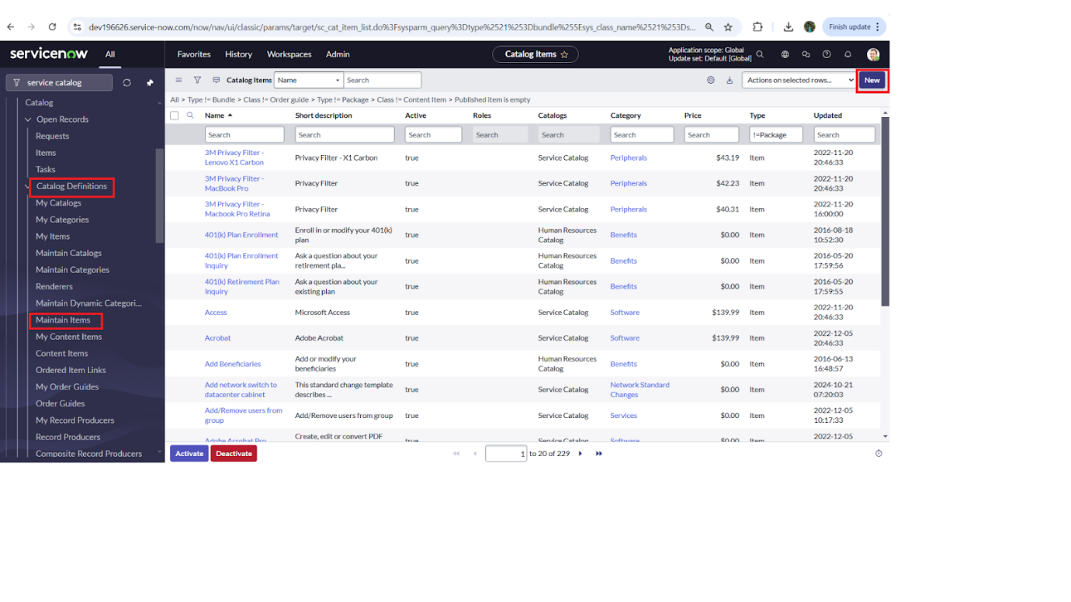

5. Fill the following details to create a new catalog item

            Name: Laptop Request

            Catalog: service Catalog

            Category: Hardware

            Short Description: Use this item to request a new laptop

1. Click on ‘SAVE’

